Senso4s BLE Integration – Project Overview
Project overview
This project is a local monitoring system for a motorhome, built around an ESP32-S3 with a touchscreen display.
The main purpose of the project is to collect information from several devices using Bluetooth Low Energy (BLE), display the information locally in the motorhome and, when available, make the data available to Home Assistant.
One of the main integrations is the Senso4s gas scale.
The ESP32 listens directly to the BLE advertising packets transmitted by the Senso4s scale. No GATT connection is required and the Senso4s mobile application is not involved.
The project is intended to work locally and does not depend on an internet connection for the basic Senso4s functionality.
Hardware
Main controller and display
The central device is a:
Waveshare ESP32-S3-Touch-LCD-4B, revision 2.2
It provides:
- ESP32-S3
- Wi-Fi
- Bluetooth Low Energy
- 4-inch touchscreen
- 480 × 800 display
- 16 MB flash
- 8 MB PSRAM
The firmware is developed using ESPHome.
Senso4s
The system currently supports two Senso4s gas scales.
The scales transmit their information using BLE advertising.
Each scale can be identified by its Bluetooth address, allowing several scales to be monitored by the same ESP32.
The project has also been tested with a Senso4s BASIC scale in addition to the PLUS scales.
Other Bluetooth devices
The same ESP32 display is also used to collect information from other motorhome equipment, including:
- Victron SmartShunt
- Victron SmartSolar
- Victron SmartSense
- Shelly PM Mini Gen3
The ESP32 therefore acts as a local Bluetooth data collector for several systems.
Senso4s BLE data
The observed Senso4s advertising packets use manufacturer ID:
09CC
The observed manufacturer data is 12 bytes:
B0 B1 B2 B3 B4 B5 B6 B7 B8 B9 B10 B11
The currently identified fields are:
Byte | Information | Status
B0 | Model / usage | Identified
B1 | Gas level (%) | Identified
B2-B3 | Prognosis-related value | Experimental
B4 | Battery (%) | Identified
B5 | Unknown | Not identified
B6-B11 | Bluetooth device address | Identified
Model and usage
B0 contains model and usage information.
The upper nibble has been observed to distinguish between PLUS and BASIC models.
The lower nibble appears to indicate the selected usage mode, with several values already identified through testing.
Gas level
B1 contains the gas level as a percentage.
For example:
56 hex = 86 %
Battery
B4 contains the battery level as a percentage.
For example:
48 hex = 72 %
Device identification
B6-B11 contains the Bluetooth address of the scale.
The actual addresses are intentionally not published in this document.
This allows several Senso4s scales to be detected and individually identified without hard-coding a particular device into the BLE reader.
Example packet
An observed packet can be represented as:
81 56 FF FF 48 00 XX XX XX XX XX XX
The current interpretation is approximately:
Model: BASIC
Usage: BBQ
Gas: 86 %
Battery: 72 %
Prognosis: unavailable
The XX values represent the device-specific Bluetooth address and have been anonymised here.
The B2-B3 prognosis information is still considered experimental.
Local GUI
The ESP32 has a touchscreen interface designed specifically for use inside the motorhome.
The Senso4s information is displayed together with information from the other systems.
Two separate Senso4s scales can be shown independently, making it possible to monitor two gas cylinders.
The display also provides pages for battery, solar power, electrical consumption and system status.
GUI examples
Figure 1 – Main system overview Figure 2 – Senso4s / gas monitoring
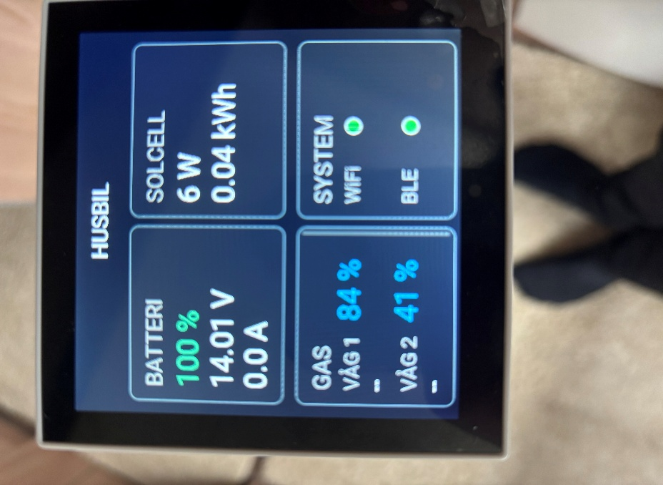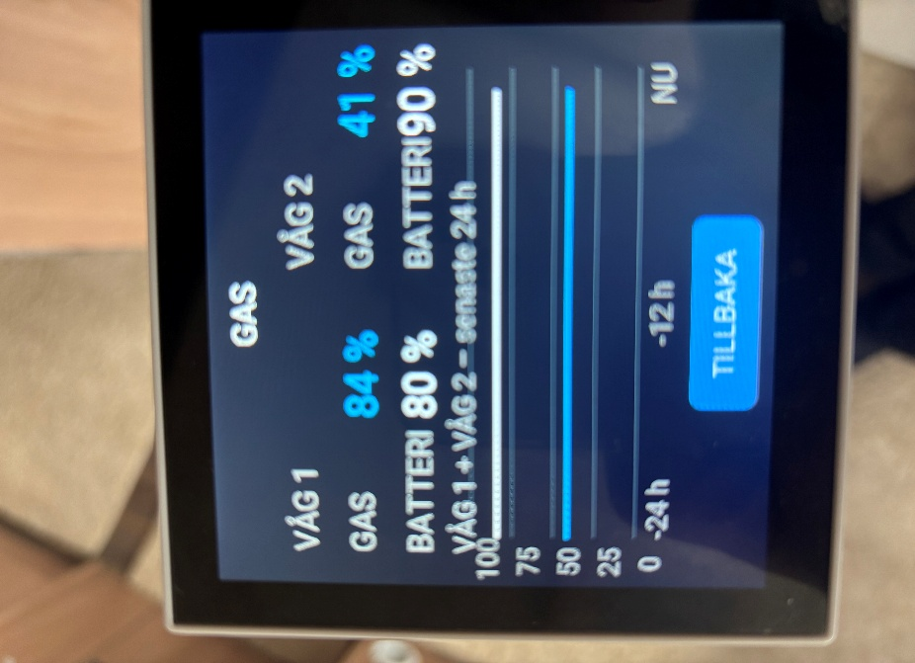

The GUI is still under development as additional functions are added to the system.
Home Assistant
When the motorhome is connected to the home network, the ESP32 can expose the collected information to Home Assistant using the ESPHome API.
The basic architecture is:
Senso4s
│
│ BLE advertising
▼
ESP32-S3
│
├── Touchscreen
│
└── Wi-Fi
│
▼
Home Assistant
Home Assistant is optional. The Senso4s data can be received and displayed locally by the ESP32 without Home Assistant.
Current status
The following Senso4s information has been identified through testing:
- Manufacturer ID 09CC
- 12-byte advertising data
- Gas level
- Battery level
- Model information
- Usage information
- Device identification
- BASIC and PLUS devices
The exact meaning of some fields, particularly B2-B3 and B5, is still being investigated.
The project therefore distinguishes between confirmed observations and experimental interpretations.
BLE code
The Senso4s BLE reader is implemented in ESPHome.
The ESP32 scans for BLE manufacturer advertisements and filters for manufacturer ID 09CC.
When a matching packet is received, the relevant bytes are decoded and exposed as ESPHome sensors.
The implementation is deliberately generic rather than tied to a single Senso4s device. This makes it possible to detect multiple scales in the same environment.
The complete source code is not currently published as part of this project documentation. The purpose of this document is primarily to describe the hardware, system architecture and the BLE observations made during development.
Purpose of sharing
This project is shared with Senso4s to document the BLE data that has been observed from real devices and to demonstrate a working local integration.
The intention is not to claim that the complete Senso4s BLE protocol has been reverse engineered.
Hopefully the information can be useful for future official integrations, documentation or further development of Senso4s BLE functionality.

